MUTABLE AND IMMUTABLE
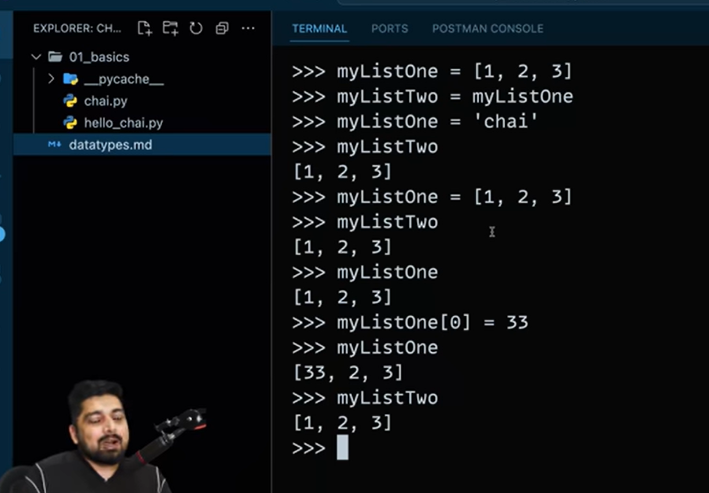
First they took the same ref afterwards they gave different ref to mlt
So it will give different results
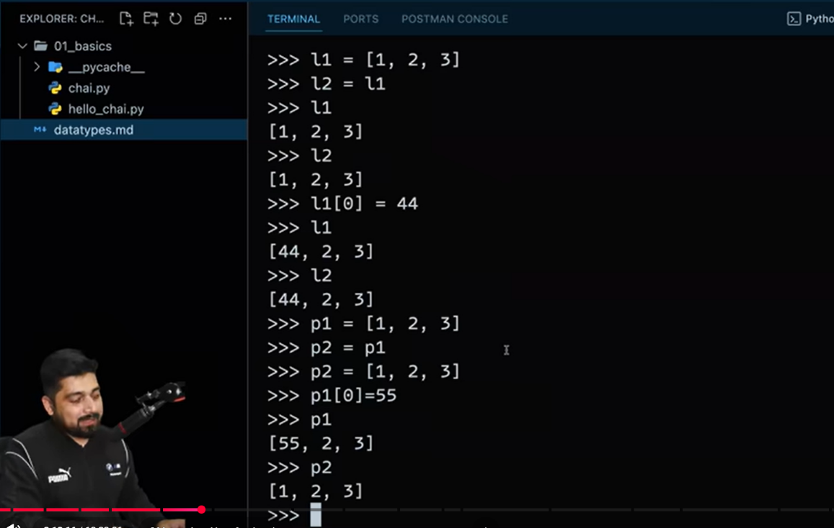
It give the same reference hence it is mutable
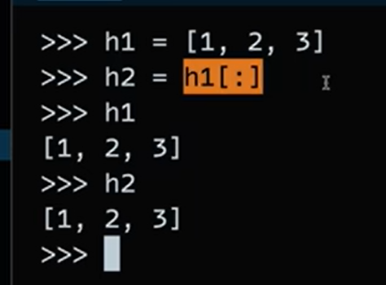
Here h1 is doing slicing
In this a duplicate(copy’s) is created not ref is given

